VAISHNAVI E 231901059
EXERCISE 11
Explore Tor network for anonymous communication

Aim: To provide a beginner-friendly guide on accessing and safely using the Tor network for anonymous browsing.
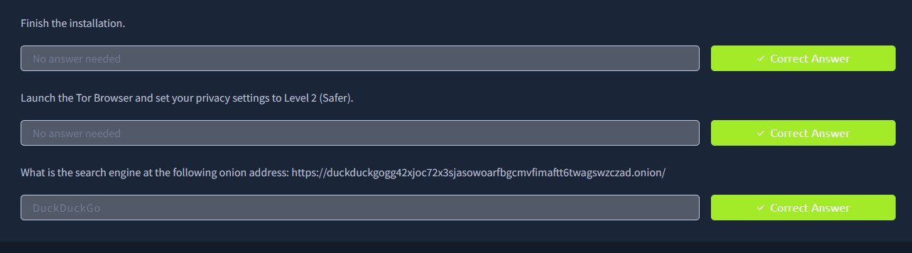
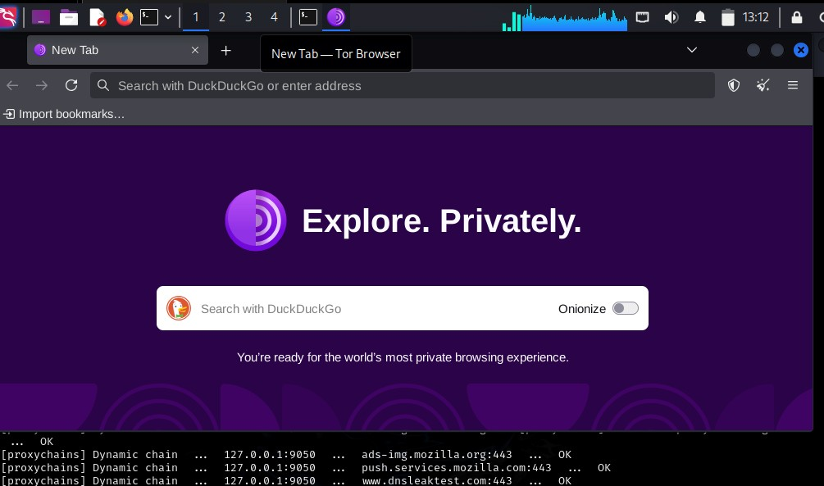

Result: Understood the fundamentals of Tor, including installation, configuration, and secure usage practices for enhanced online privacy.

